

Annual Progress Report for Enterprise Support and Development Project 2021

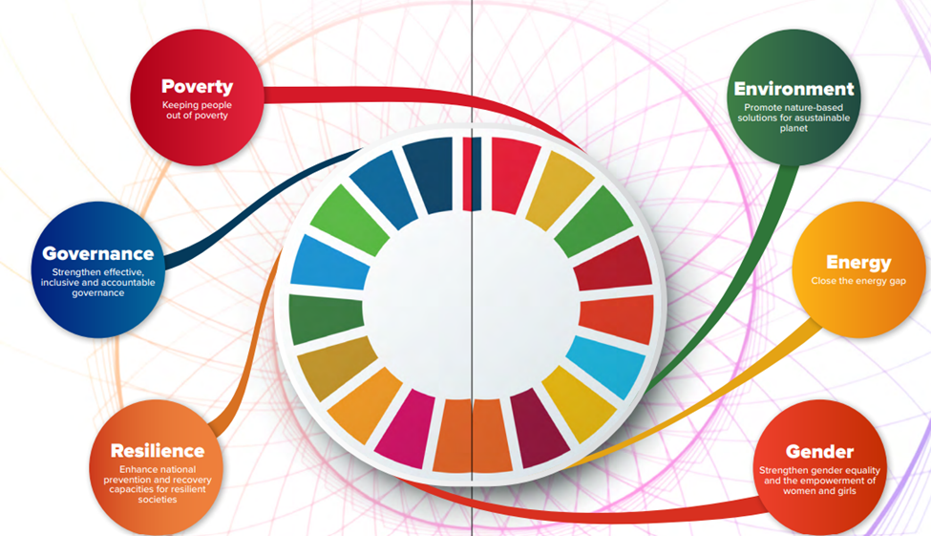

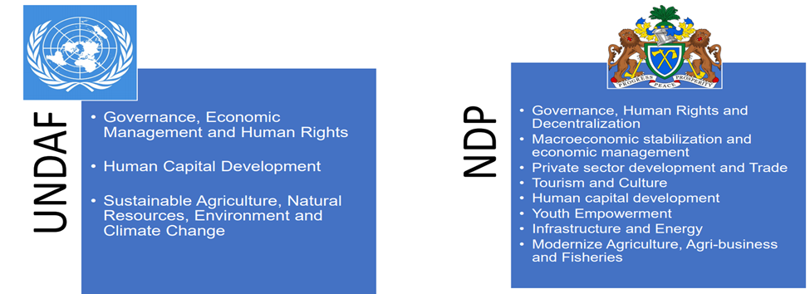

Prepared by: Project Management Unit
Ministry of Trade and Industry

1.0 Introduction
The National Development Plan (NDP 2018-2021) recognizes the private sector as an engine for growth and transformation, covered profoundly in the NDP's Strategic Priority eight (8). Through its various frameworks, the Ministry of Trade, Industry, Regional Integration and Employment (MOTIE), including the current Medium-Term Plan 2021-2025is committed to private sector-led policy programming to spur growth and development through employment creation and creation of a conducive business environment, among others. The MTP also recognizes the significant challenges hindering private sector growth and development and has thus far initiated programs and engendered reforms in collaboration with key stakeholders, including development partners, most notably the United Nations Development Programme (UNDP), towards promoting private sector growth and development.
It is against this background that in 2017, MOTIE and UNDP launched the Entrepreneurship and Private Sector Growth (EPSD) Project aimed at reducing obstacles to enterprise development and expanding their production capacities to support the realization of accelerated inclusive and sustainable economic growth as a means of reducing poverty and inequality of vulnerable groups, especially women and Youth located in the poorest districts and regions of The Gambia. The Project covers five years, from 2017 – 2021, with total funding of US$3,200 600 (US$3 million support from UNDP, and US$200,600 as counterpart fund from the Government of The Gambia).
As part of 2021, Annual work Plan, which was expected to be the Project's final year, UNDP allocated Resourced as of 1st January 2021: $ 450,000, and the Government of the Gambia allocated Resources as at 1/1/2021 GMD 5,000,000. The 2021 Annual Work was designed to achieve the unmet targets in the project outputs, particularly on capacity building. The work plan had 31 activities, of which 30 were fully implemented, thus a delivery rate of 92 percent.

Output 1: Creating an Enabling Environment for inclusive and sustainable private sector development by supporting better policy programming, especially with regards to employment and entrepreneurship

Key activities
- Made in the Gambia Strategy 2021-2025 developed. The objective of the strategy is to reorganize and reposition the productive sector of the economy as a competitive enterprise, manufacturing and export-oriented country. The strategy will further seek to lean and leverage other government strategic policies and build synergies around promoting the country’s industrial competitiveness to enhance the production of locally made goods and services. The Ministry is currently implementing some of the strategies identified and further mobilizing local and donors’ resources to fully implement the plan.

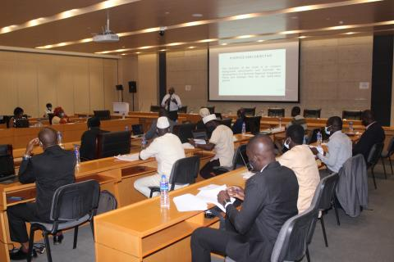
Validation workshop of the Made in The Gambia

- Conducted a study on the effects of AfCFTA on MSMEs in the Gambia. A survey was completed, and a report was available. The report revealed that AfCFTA could expand the growth of MSMEs; however, the need to be capacitated to take advantage of the opportunities.
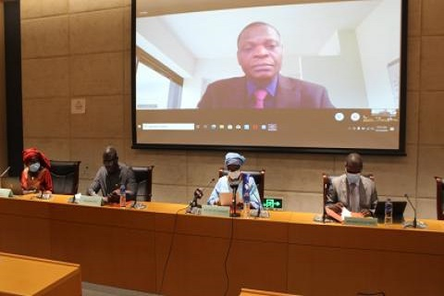
Validation of the Study on the Impact of AfCFTA on MSMEs
- Supported the review and updated the GIEPA Act 2015. The Act is yet to be validated, as GEIPA and the Ministry review its content before submission to the cabinet and National Assembly for approval.
- The Project supported the pre-feasibility plans for the Gambia Labour Force 2022. The Labour force survey will be conducted in 2022 due to the unavailability of funds in 2021. Other donor partners did not make their contributions available on time.
- Another activity conducted was a Tracer Study and Impact Assessment for all the trainees under EPSPD. The survey revealed that Trainees from the TVET programs are easily absorbed into the Labour market, while entrepreneurship training encounters difficulties. Report available. The study also revealed that the gender disaggregation of trainees favors male Youth.
- The Project also supported a policy dialogue on employment and formalization of MSMEs in the Gambia. This was a high-level policy dialogue, spearheaded by the Vice President and Honorable Minister of Trade, Industry, Regional Integration and Employment, senior government and private sector officials. The 2018 Labour force survey was discussed, and the implications of youth unemployment were discussed. Policymakers commit themselves to promoting employment creates for decent jobs.
- The Project conducted 125 border security officer’s sensitizations on the AfCFTA Online Reporting Platform. The participants were dawned from Police, Immigrations, SIS, FSQA, and other stakeholders at the borders. The AfCFTA Online Reporting and Resolution Mechanism is part of Article 5 of the Protocol on AfCFTA, aimed to improve trade facilitation across the borders through the elimination of Non- tariff Barriers (NTBs.) The sensitization program took place at Amadali, Farafenni, Basse, Soma, and Jiborro border Posts.
- The ESDP Supported the Gambia through the directorate of Trade to develop its schedules on commitment on Trade Services as part of AfCFTA negotiations. The activity took place at a local hotel, where stakeholders in the service sector discussed national priorities and determined which sectors are bound or unbound, in the Gambia schedule of commitment submitted to ECOWAS for further negotiations.
- The Project also conducted a nationwide mapping of all horticultural gardens to cluster them for export promotion and market linkages. This exercise was implemented by GEIPA in collaboration with the Ministry of Agriculture. The Clustering process will further assist in market linkages, particularly with other digital platforms been established by the Ministry of Trade and Industry. The main objectives of the mapping and clustering are to, Verify the products/producer of cooperatives gardens, Identify Products and Areas with strong production capacities, To link the gardens with project relating to supply of seed and manufactural development of gardens, Establish areas of concentration for revitalization and diversification of identified products for value addition, To work closely with the Agric-Business Department of the DOA to implement recommendations, Increase production across all sectors identified to support the realization of food sufficiency and create market for domestic and export markets, To link them to out growers and link them with local hotels and major Exporters
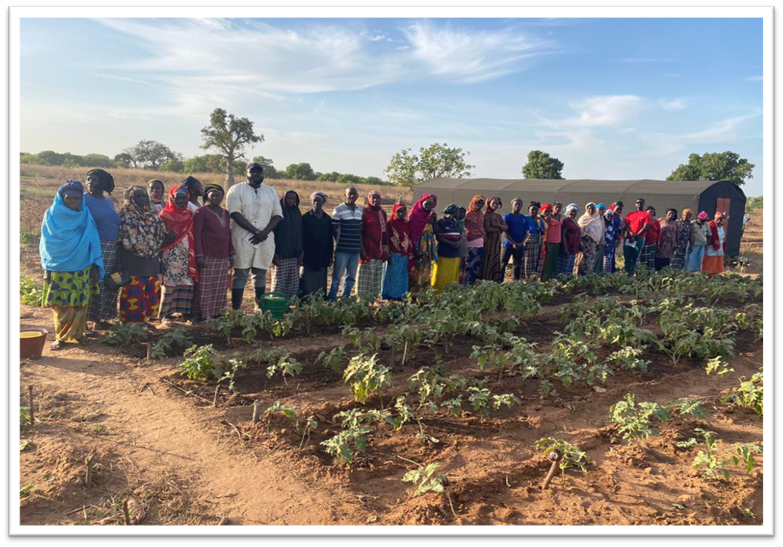
Mapping of Horticultural Gardens conducted by GIEPA supported by EPSDP

Output 2:
Developing the capacity of local entrepreneurs for improved productivity and competitiveness through training & skills development of existing interventions like Songhai and Emprete

Activities
- The Project supported ongoing ETWS & BDS pieces of training provided under the Empretec training model. Over 120 beneficiaries trained on ETW and BDS services at different locations. Out of this number, ten beneficiaries are vulnerable groups. This activity is implemented by GEIPA
- Three hundred women and Youth supported participating in National Youth and Women Agribusiness and Tourism Trade Fair. The beneficiaries are provided with stall rental, adverts, and advocacy materials for the events. This trade fair was the first of its kind organized by the Youth Chamber of Commerce.
- Twenty women entrepreneurs supported to participate in Zingchour International Trade Fair. The beneficiaries are provided with stall rental, transport costs, and other logistics.
- 86 Youths trained on Agro-entrepreneurs, crop production, and animal husbandry at Songhai Gambia. The institute is equally supported with equipment, feeds, and learning materials.
- Hire technical assistance to lead the operations at GSI. The Consultant hired has been working at GSI for the past five years, and he was the chief technical Assistant. This is aimed at ensuring sustainability.
- The Project supported the Gambia Chamber of Commerce and Industry to train 200 women for Six Months on Digital Transformation and Business Advisory to capitalize on e-commerce. These trainees use social media platforms for marketing their business and establishing linkages such as B4B and B4C.
- The Gambia Youth Chamber of Commerce (GYCC), in partnership with the National Youth Council With MoTIE-UNDP Entrepreneurship and Private Sector Development Project organized a week. Training on Product Packaging and Branding for young entrepreneurs across the country. The Training hosted 24 participants in Agribusiness, Catering, Fashion, and Handicraft. During the training, participants had the chance to visit Printing, packaging, and Fashion industries with the Greater Banjul to have the practical understanding of packing standards and how packaging and branding materials are being processed
- The Project conducted an awareness creation seminar on The Africa Continent Free Trade Area Agreement (AfCFTA). On Tuesday 9th March 2021, GYCC conducted a two-day awareness creation seminar on The Africa Continent Free Trade Area Agreement (AfCFTA) at NaNA Conference Hal. The convergent brought together 30 young entrepreneurs to discuss the theme: "Enhancing the Capacity of Youth and Women Cross Border Traders on Non-Trade Barriers and its Reporting Mechanism to Facilitate Intra-Africa Trade."

Output 3 –To support more excellent dialogue and sharing of knowledge and information between the private and public sectors as well as linkages with the finance and export sector

Activities
- 270 Women trained on Standards Operation procedures for women's access to credit from the Women Enterprise Fund and Enterprise Management Skills, including financial management. After the training, the women groups could access more than 10 million dalasis from the Women Entrepreneurship Fund, under the Ministry of Gender, Children and Social Welfare.
- The Project conducted training for 120 Youth on diverse marketable skills /market demanded skills areas such as domestic electrical installation, video editing, production, CCTV Access control and biometric system, hairdressing, Soap, and detergent. Each of these training lasted for 5 to 6 months. The participants are awarded certificates recognized by NACCA.
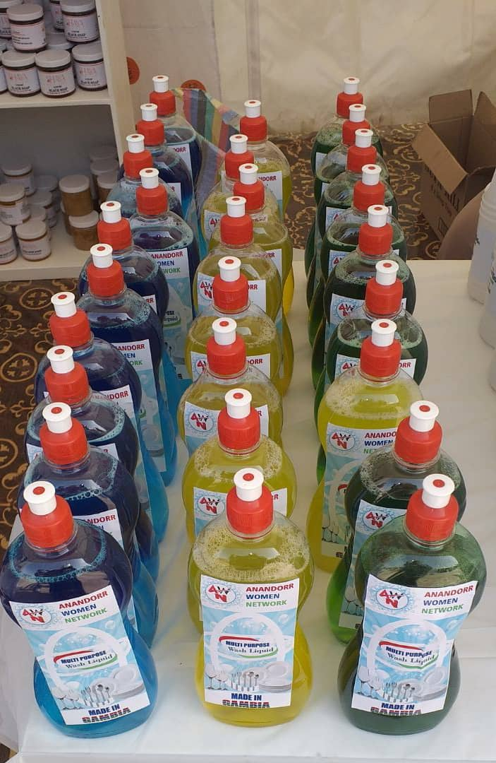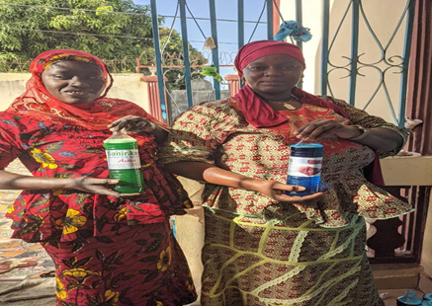
Women trained on Detergent and Soap Making
- Three local bakeries supported to expand. They were provided with five tricycles and 75 bags of flours, and a motorcycle. Due to this support, the bakery is now supplying bread beyond Brikama, to as far as 20 km away in Jiboro, without any increment in the price of bread.
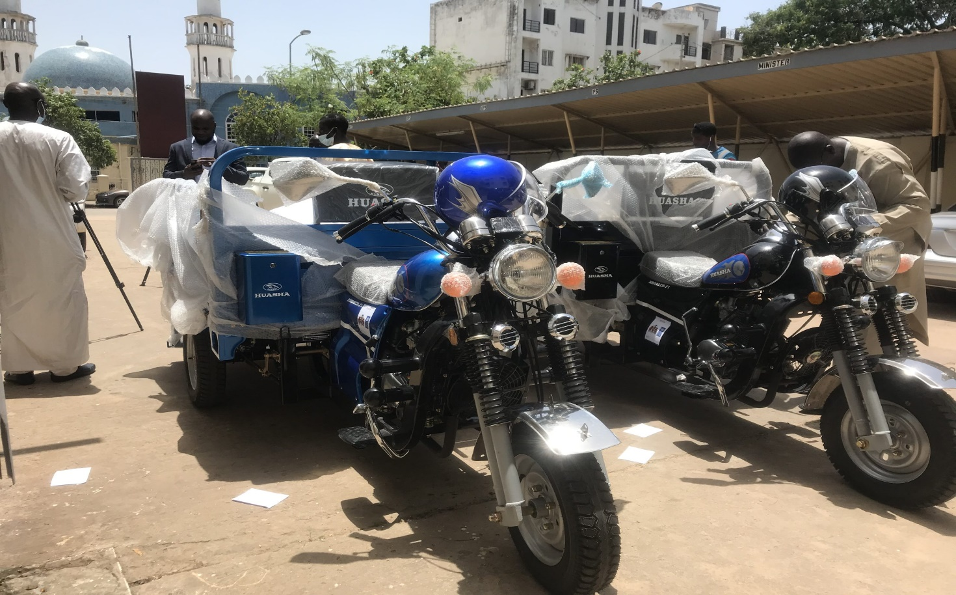
Tricycle and flour to support local Baker Mr Saikou Bojang

- The Project supported the Women's Chamber of Commerce to establish regional chapters. The Chamber registered 150 new members and established branches in all the regions.
- Supported Kartong Oyster Women Group with 3 Boats and refurbished the oyster smokehouse. As their former boats were old, the women are now using these boats to collect oysters in a safe environment.
- The Project supported two women gardens with solar power irrigation systems in Badgiran and Kuto. Each of the gardens is provided with a solar borehole and fencing.
- Three women, restaurant entrepreneurs, two businesswomen supported to expand their businesses.

Lessons Learned
- The tracer study on pass training revealed that students who undergo, TVET related courses are more likely to be employed or self-employed
- The targeted number of trainees under Outcome 3 could not be met. This is due to a limited number of accredited training institutions, the duration of the training, and the amount of space available at such training institutes. However, it was realized that several training packages conducted under output three should be reported under output 2. The PMU will review its reporting, and it is hoped that, when such is done, we will meet the target for training under oupt2.
- Using GLF and project funds and partnering with other donors, the Project supported downstream activities such as bakeries, vegetable gardens, oyster harvesters, etc. These activities enhance project visibility, improve livelihood
- The project partners with UNAID to train PLHIV Aid for the first time. 3I participants were trained in ETW, Hairdressing, and video editing.

Challenges
- Delay in fund disbursement
- Covid 19
- Limited Funding
- A limited number of accredited training institutions

